Client Design Description

GitHub Link: https://github.com/guojunseven/Building-Scalable-Distributed-System/tree/master/Assignment01

1. Client1 Design



As you can see from my screenshot of project structure, I put client related code in **client** package (src/main/java/), There are four class : ***ApiClientThread, ClientMultiThreaded, RequestsCount, TextReaderThread***. The **ClientMultiThreaded** creasts multiple **ApiClientThread**, **TextReaderThread** to send requests and read file. It uses **RequestsCount** to count different type of requests.

# 1.1 ClientMultiThreaded

This is the start class for configure the multiple threads for sending requests and report the running statistics. I initialize all configuration variable in this class and it provides a main method to run the client program.



At first, it checks the arguments passed by the command line.

Then, it reads the specified text file using ***BufferedReader*** to save the time spent in I/O operation. And it also instantiates a **counter** for count the successful and unsuccessful requests.

Next, it creates a **cyclic barrier** and **blocking queue** serving for coordinating multiple threads and provides the requests-sending threads text line one by one.

In this implementation, I create a single thread for reading text line and put it into the work queue. I tested it and make sure the speed it produces the line is larger than the speed other threads consume line from the queue. Then I take timestamp and create ***maxThreads*** threads to send requests to the server simultaneously.

Finally, the main thread waits for other threads to complete and ready to print the results report.



# 1.2 ApiClientThread

This is the http requests handler class and extends ***Thread***so that it will be created as a single thread to send requests. It constructor accepts **workQueue** to take line text, **basePath** to which the api client connects, **function** the post parameter, **barrier** the synchronized barrier, **counter** to count successful requests and unsuccessful requests, **end** to mark the end of sending requests.

This class will instantiate an **api client once** and use this client to send all requests. In its **run()** method, it will continuously attempt to take a line from the blocking queue in a loop and check if it reaches the end of the file. If yes, it then breaks to wait other threads complete. Otherwise, it will send the request to server and wait for response.

# 1.3 RequestsCount

This is the class used for counting the requests number and it is **thread-safe**. It has two method: **markSucc()** and **markFail()** to increase successful requests number or unsuccessful requests number by one. And it provides getter to get these counts.

# 1.4 TextReaderThread

This class is responsible for read lines one by one from a **reader** (text) and put these line to a blocking queue to serve the requests-sending threads. Its constructor accepts work queue the blocking queue to put lines, reader the bufferedReader object to read lines, end the mark of **EOF**,

maxThreads the number of the end mark.

In its **run()** method, it will continuously read lines from the reader until it reaches the end. Then it put the **end mark** in a number of threads number to the queue to inform other threads that there is no other lines to read.

1. Client2 Design



Unlike Client1, it has a separate package “**statistic**” to place code related to **writing statistics** into CSV file. The other classes have the similar code and functionality with clien1. I will introduce the modified part of client2 compared to client1 in the following paragraphs.

# 2.1 ClientMultiThreaded



I create a **BufferedWriter** to write statistical lines to the specified csv file. And I also instantiate a thread pool with unbounded work queue and 10 core threads size for write lines to the writer after sending requests. I design like this so that my api client thread **won’t need to spend time in writing csv file**. They just submit the runnable statistics task to the thread pool so that the writing to csv file won’t affect the overall throughput of our program.



And after sending all request, I need check if the thread pool has active count (is there still tasks to writing csv). If not, it will shut down the thread pool and close the writer. And do the analysis report.

Besides above, the other parts of this class remain the same.

# 2.2 ApiClientThread

Unlike client1, its constructor now accepts an additional **writer** and a **thread pool** to for writing csv file after sending requests.



# 2.3 StatisticasRunnable

This class represents a task to write line to a writer of a specified CSV file. Its constructor accepts a **writer** and the **data** in an array needed to be written. In the run() method, it creates a line from the array and write it to the writer. And we don’t need to worry about synchronizing here because of the nature that writer is **thread safe**.



1. Client1 Results

* 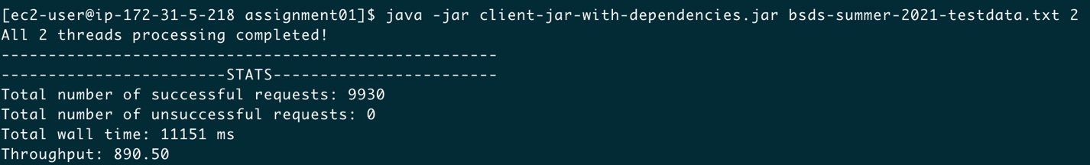2 threads
* 4 threads

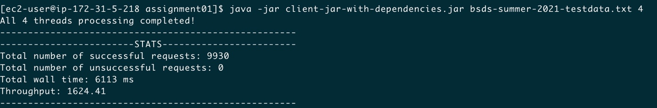

* 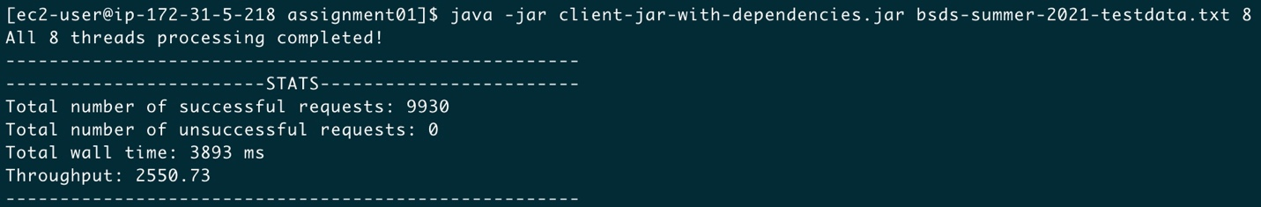8 threads
* 16 threads

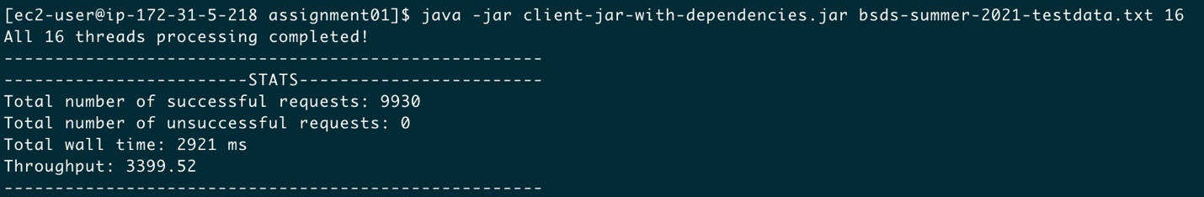

* 32 threads

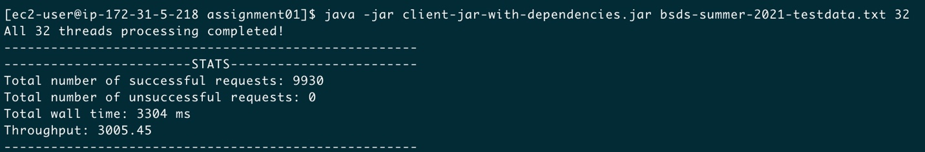

* 64 threads

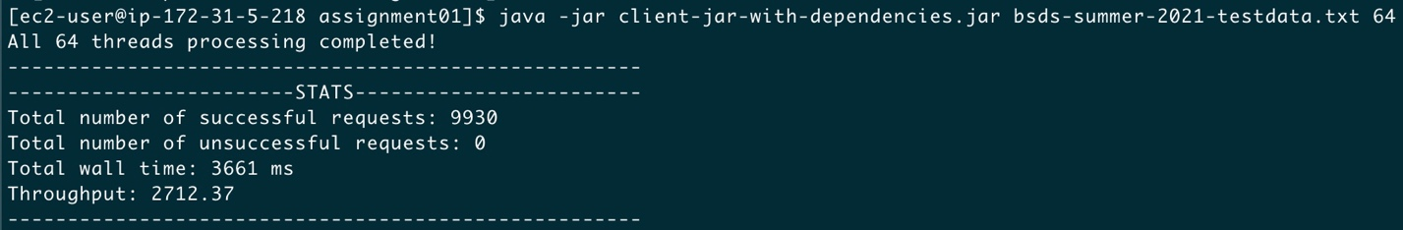

* 128 threads

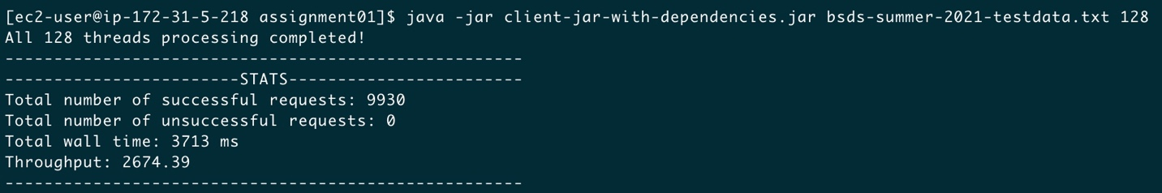

* 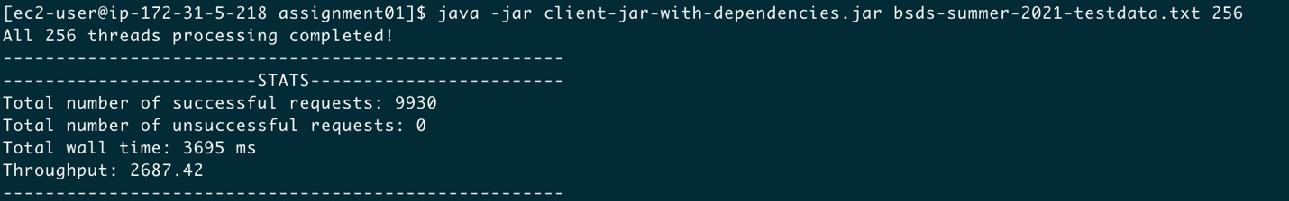256 threads

1. Client2 Result

* 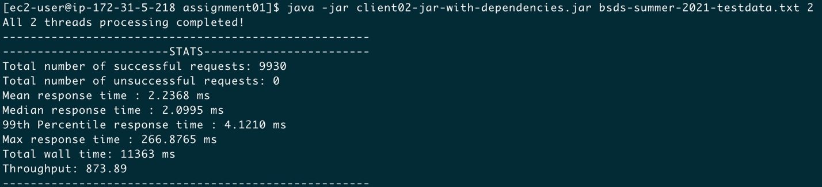2 threads
* 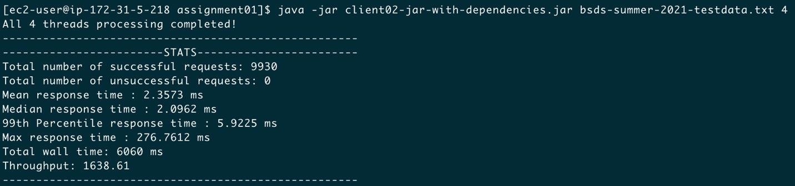4 threads
* 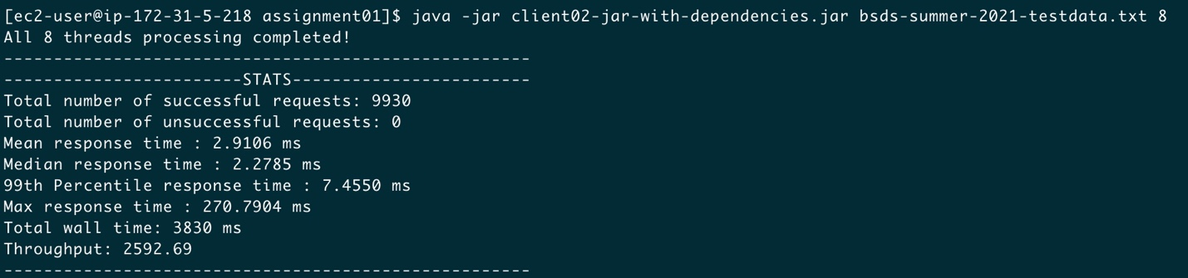8 threads
* 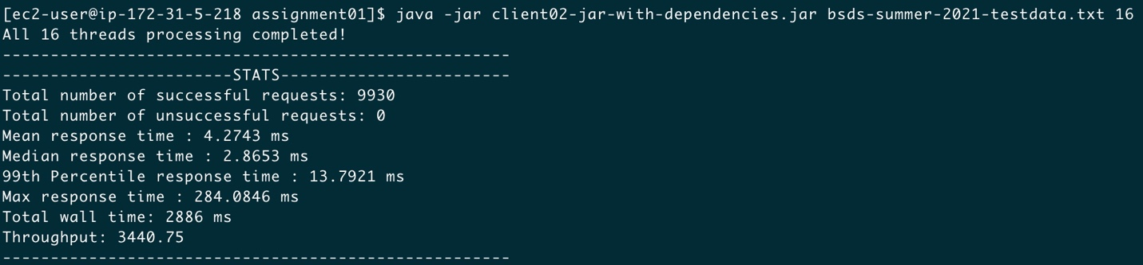16 threads
* 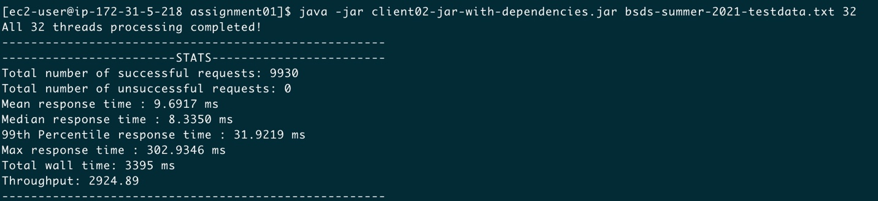32 threads
* 64 threads

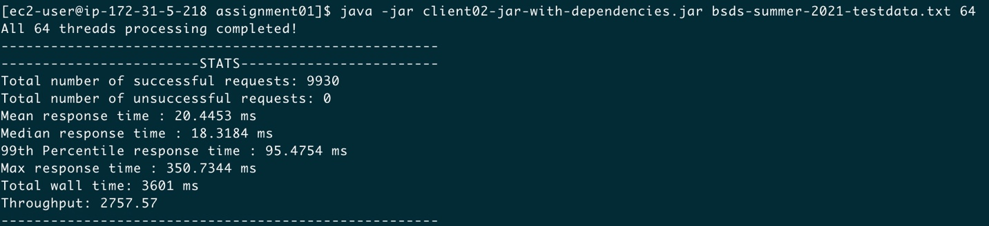

* 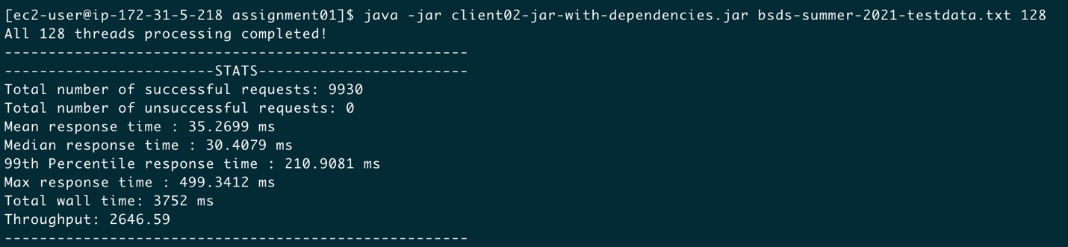128 threads
* 256 threads

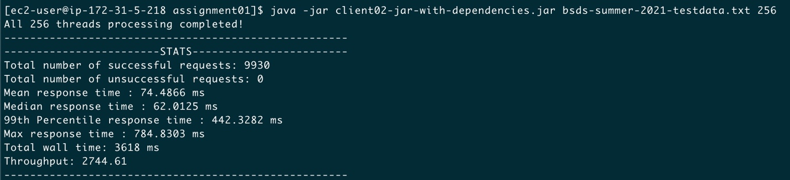

**Wall time difference:**

The difference between two clients is within 5%, but it is fluctuated.



**Client1 Wall time by threads**

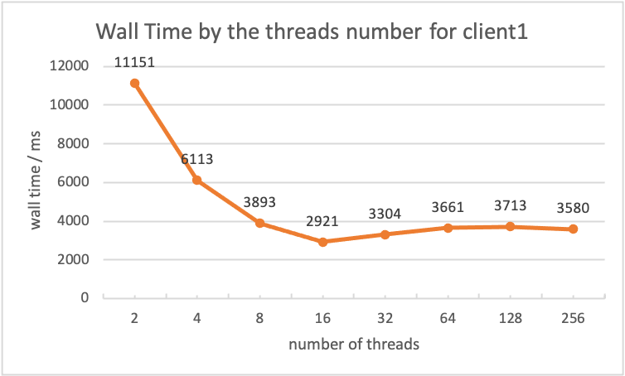

**Client2 Wall time by threads**

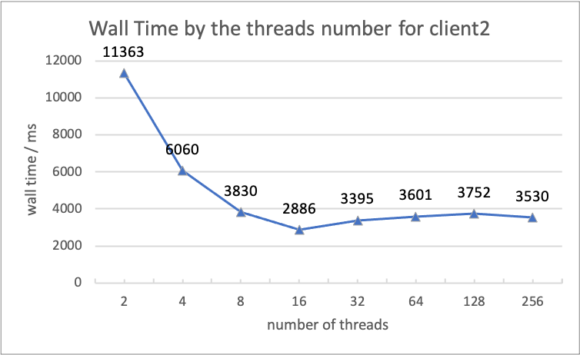

**Client2 Throughput by threads**

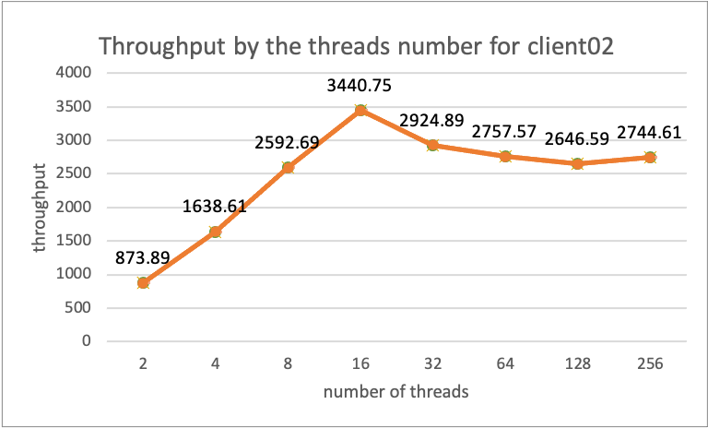

**Client2 Mean response time by threads**

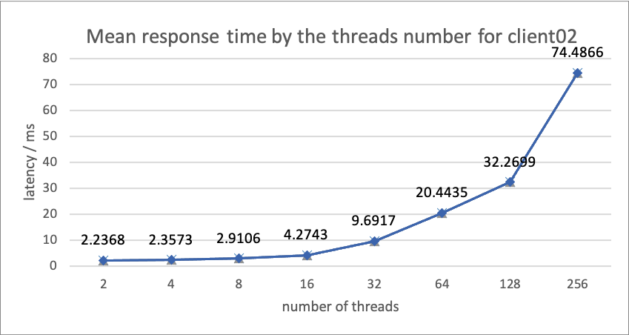

1. Break things

Try 2000 threads, nothing happens except the decreased throughput due to intensive context switching between threads.



Try 3000 threads, it fails in one-third of the run. It return code 0 with a null body. The Connection Reset Exception means the request is refused by the server.





And there are 35 unsuccessful requests.



Try 4000 threads, the unsuccessful requests increase.

And many connections reset error.

Therefore, my server can support about less than 3000 client threads.



1. Charting

I experiment with 32 threads on client2 and generate two charts: one for average latency against time and the other for throughput against time. These two plots are genearted based on the data collected for every request in the **statistics.csv** file. The time interval is 0.5s.

**Average latency against time**

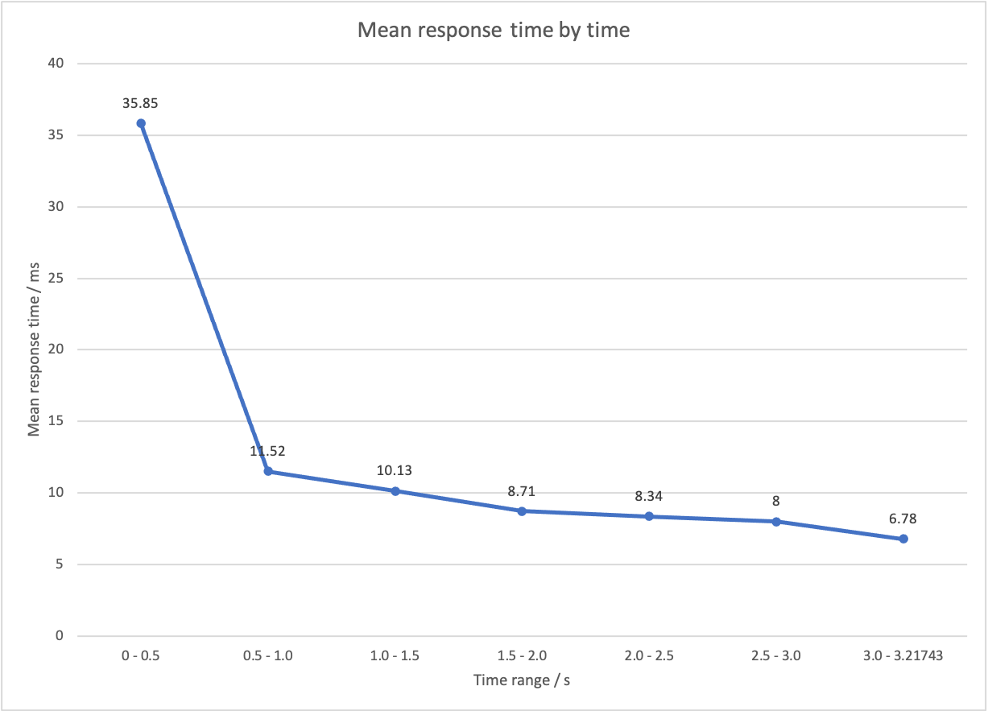

**Average throughput against time**

